**Nexus server installation on Ubuntu EC2**

Execute following commands as ‘**Ubuntu**’ user

* sudo apt-get update
* sudo apt install wget
* sudo apt install openjdk-8-jre-headless
* **java -version**



* cd /tmp
* sudo wget <https://sonatype-download.global.ssl.fastly.net/repository/repositoryManager/3/nexus-3.16.1-02-unix.tar.gz>



* sudo tar -zxvf nexus-3.16.1-02-unix.tar.gz -C /opt/



* sudo mv /opt/nexus-3.16.1-02 /opt/nexus



* sudo adduser nexus

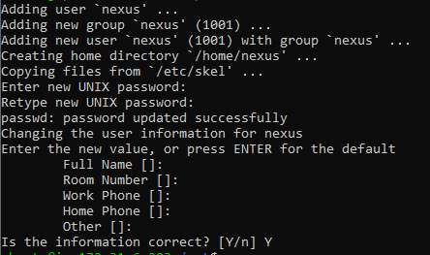

* sudo visudo

Add the highlighted line as below

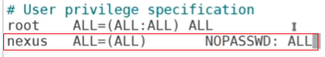

* sudo chown -R nexus:nexus /opt/nexus
* sudo chown -R nexus:nexus /opt/sonatype-work/
* sudo vim /opt/nexus/bin/nexus.rc

Uncomment **run_as_user** parameter and set it as following.



* sudo ln -s /opt/nexus/bin/nexus /etc/init.d/nexus
* su – nexus
* /etc/init.d/nexus start
* sudo netstat -plnt

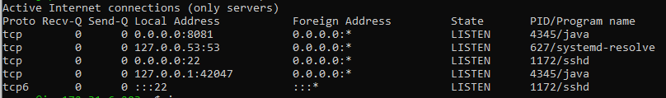

Access the nexus UI

http://<server_IP>:8081/

